Knowledge Engineering and Data Science
Lab
1. Grade Analysis Using Pie Chart and Bar Chart
Aim:
To develop a Python program to represent student grade distribution using pie and bar charts, and identify the maximum, minimum, and combined percentage of students.
Algorithm:
- Store the grades and number of students in lists.
- Calculate the percentage of students in each grade.
- Draw a pie chart with grade labels and percentage values.
- Draw a bar chart with the number of students above each bar.
- Identify the grades with maximum and minimum students.
- Calculate the combined percentage of students who secured grades A and S.
- Display the results.
Program:
import matplotlib.pyplot as plt

grades = ['F', 'E', 'D', 'C', 'B', 'A', 'S']
students = [3, 4, 5, 8, 9, 7, 4]
total = sum(students)
percentages = [n / total * 100 for n in students]
plt.figure(figsize=(7, 6))
plt.pie(students, labels=grades, autopct='%1.1f%%',
startangle=90)
plt.title("Percentage Distribution of Grades")
plt.legend(grades, title="Grades")
plt.show()

plt.figure(figsize=(7, 5))
bars = plt.bar(grades, students, color='skyblue')

plt.xlabel("Grades")
plt.ylabel("Number of Students")
plt.title("Number of Students in Each Grade")

for bar in bars:
height = bar.get_height()
plt.text(bar.get_x() + bar.get_width()/2,
height, str(int(height)),
ha='center', va='bottom')

plt.show()

max_grade = grades[students.index(max(students))]
min_grade = grades[students.index(min(students))]

print("Total Students:", total)
print("Maximum Students:", max_grade, "-", max(students))
print("Minimum Students:", min_grade, "-", min(students))

combined = (students[5] + students[6]) / total * 100
print("Percentage of A and S Grades:", round(combined, 2), "%")

OUTPUT:
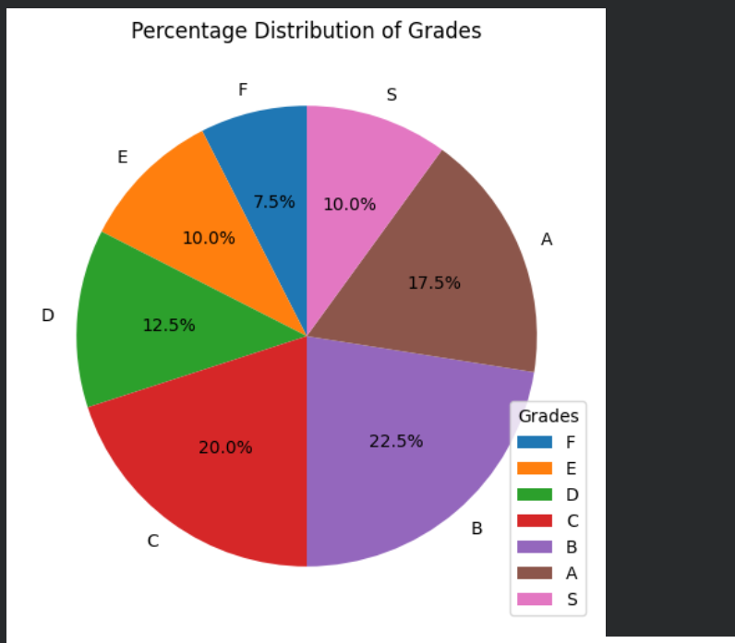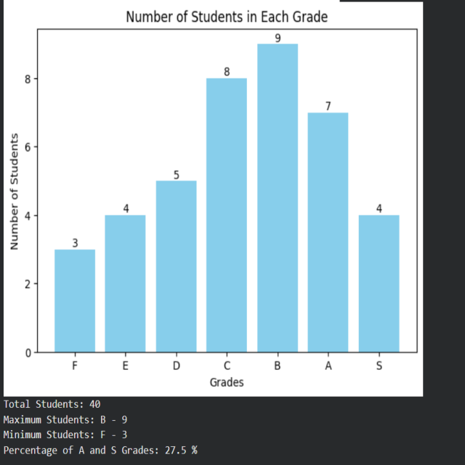

2. Semantic Network Using NetworkX
Aim:
To represent concepts and their labeled relationships using a directed semantic network in Python.
Algorithm:
- Import the NetworkX library.
- Create a directed graph.
- Add concepts and their relationships as edges.
- Display each relationship.
- Display the result.
Program:
!pip install networkx -q

import networkx as nx

G = nx.DiGraph()

# Add concepts and relationships
G.add_edge("Dog", "Mammal", relation="is-a")
G.add_edge("Mammal", "Animal", relation="is-a")
G.add_edge("Dog", "Tommy", relation="has-instance")

print("Semantic Network Relationships:")

for source, target, data in G.edges(data=True):
print(source, "--", data["relation"], "-->", target)

print("\nResult: The semantic network represented concepts and their relationships.")

OUTPUT:
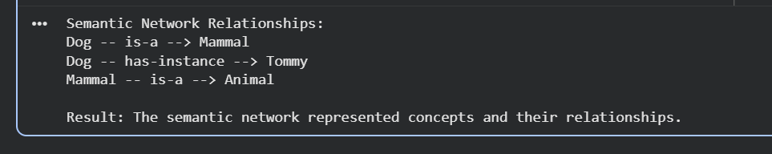
3. Frame-Based Knowledge Representation
Aim:
To represent an object using a frame containing slots and their corresponding values in Python.
Algorithm:
- Create a dictionary to represent a frame.
- Store the object details as keys and values.
- Display the frame name.
- Display each slot and its value.
- Display the result.
Program:
vehicle = {
"class": "Vehicle",
"brand": "Toyota",
"fuel_type": "Petrol",
"wheels": 4,
"color": "White"
}

print("Vehicle Frame")

for slot, value in vehicle.items():
print(slot, ":", value)
OUTPUT:


